# Muhammad Umair

# FA19-BCS-082

# Dice app code:

import 'dart:async';  
import 'dart:math';  
import 'package:flutter/material.dart';  
void main() {  
 runApp(MyApp());  
}  
  
class MyApp extends StatelessWidget {  
 @override  
 Widget build(BuildContext context) {  
 return MaterialApp(  
 title: 'Splash Screen',  
 theme: ThemeData(  
 primarySwatch: Colors.*green*,  
 ),  
 home: MyHomePage(),  
 debugShowCheckedModeBanner: false,  
 );  
 }  
}  
  
class MyHomePage extends StatefulWidget {  
 @override  
 _MyHomePageState createState() => _MyHomePageState();  
}  
class _MyHomePageState extends State<MyHomePage> {  
 @override  
 void initState() {  
 super.initState();  
 Timer(Duration(seconds: 3),  
 ()=>Navigator.*pushReplacement*(context,  
 MaterialPageRoute(builder:  
 (context) =>  
 MyNewDiceApp()  
 )  
 )  
 );  
 }  
 @override  
 Widget build(BuildContext context) {  
 return Container(  
 color: Colors.*lightGreenAccent*,  
 child:CircleAvatar(  
 radius: 20.0,  
 foregroundImage: AssetImage('images/dices.jpg'),  
 ),  
 );  
 }  
}  
  
class MyNewDiceApp extends StatefulWidget {  
 @override  
 _MyNewDiceAppState createState() => _MyNewDiceAppState();  
}  
  
  
class _MyNewDiceAppState extends State<MyNewDiceApp> {  
  
 var dice1 = 1;  
 var dice2 = 1;  
 var dice3 = 1;  
 var dice4 = 1;  
 var a=1;  
 var b=1;  
 var c=1;  
 var d=1;  
 var count=0;  
 var winner;  
  
 void totalSumofDices() {  
 setState(() {  
 count = a + b + c + d;  
 if(a>b&&b>c&&c>d)  
 {  
 winner=("dice1 having score =$a");  
 }  
 if(b>a&&b>c&&c>d)  
 {  
 winner=(" dice2 having score =$b");  
 }  
 if(c>a&&c>b&&c>d)  
 {  
 winner=(" dice3 having score =$c");  
 }  
 if(d>a&&d>b&&d>c)  
 {  
 winner=("dice4 having score =$d");  
 }  
  
 });  
 }  
 int result()  
 {  
 if (a > b) {  
 if (b > c) {  
 if (c > d) {  
 print("Dice1 is winner/nTotal Sum =$count /n Dice1 score = $a");  
 winner=("Dice1 score =$a") ;  
 }  
 }  
 }  
  
 if (b > a) {  
 if (b > c) {  
 if (b > d) {  
 print("Dice2 is winner/nTotal Sum =$count /n Dice2 score = $b");  
 winner=("Dice1 score =$b") ;  
 }  
 }  
 }  
  
  
 if (c > a) {  
 if (c > b) {  
 if (c > d) {  
 print("Dice3 is winner/nTotal Sum =$count /n Dice3 score = $c");  
 winner=("Dice1 score =$c") ;  
 }  
 }  
 }  
  
 if (d > a) {  
 if (d > b) {  
 if (d > c) {  
 print("Dice4 is winner/nTotal Sum =$count /n Dice14score = $d");  
 winner=("Dice1 score =$d") ;  
 }  
 }  
 }  
 }  
  
  
 @override  
 Widget build(BuildContext context) {  
 return MaterialApp(  
 debugShowCheckedModeBanner: false,  
 home: Scaffold(  
 backgroundColor: Colors.*lightGreenAccent*,  
 appBar: AppBar(  
 title: Text("Total:$count"),  
 centerTitle: true,  
 backgroundColor: Colors.*blue*,  
 ),  
 body: Container(  
 child:  
 Column(mainAxisAlignment: MainAxisAlignment.center,  
 children: [Row(  
 children: [  
 Expanded(  
 child: Text('Dice1=${a}', textAlign: TextAlign.center)  
 ),  
 Expanded(  
 child: Text('Dice2=${b}', textAlign: TextAlign.center)  
 ),  
 Expanded(  
 child: Text('Dice3=${c}', textAlign: TextAlign.center)  
 ),  
 Expanded(  
 child: Text('Dice4=${d}', textAlign: TextAlign.center)  
 ),  
  
 ]  
 ),  
  
  
 Row(mainAxisAlignment: MainAxisAlignment.center,  
 children: [  
 Expanded(  
 child: TextButton(  
 child: Image.asset('images/dice$dice1.png'),  
 onPressed: () {  
 setState(() {  
 dice1 = Random().nextInt(6) + 1;  
 a = a + dice1;  
 totalSumofDices();  
 });  
 print(num);  
 },  
 ),  
 ),  
 Expanded(  
 child: TextButton(  
 child: Image.asset('images/dice$dice2.png'),  
 onPressed: () {  
 setState(() {  
 dice2 = Random().nextInt(6) + 1;  
 b = b + dice2;  
 totalSumofDices();  
 });  
 print(num);  
 },  
 ),  
 ),  
 Expanded(  
 child: TextButton(  
 child: Image.asset('images/dice$dice3.png'),  
 onPressed: () {  
 setState(() {  
 dice3 = Random().nextInt(6) + 1;  
 c = c + dice3;  
 totalSumofDices();  
 });  
 print(num);  
 },  
 ),  
 ),  
 Expanded(  
 child: TextButton(  
 child: Image.asset('images/dice$dice4.png'),  
 onPressed: () {  
 setState(() {  
 dice4 = Random().nextInt(6) + 1;  
 d = d + dice4;  
 totalSumofDices();  
 //sum();  
 });  
 print(num);  
 },  
 ),  
 ),  
 ],  
  
 ),  
 ],  
 ),  
  
 ),  
 floatingActionButton: FloatingActionButton(  
 onPressed: () {  
 // show the dialog;  
 showDialog(context:context,  
 builder: (BuildContext context){  
 return dialogbox('total score=$count and winner is $winner');  
 }  
 );  
 },  
 backgroundColor: Colors.*green*,  
 child: const Icon(Icons.*lightbulb_outline* )  
 )  
 )  
 );  
 }  
 }  
  
class dialogbox extends StatelessWidget{  
 var title;  
 dialogbox(this.title);  
 @override  
 Widget build(BuildContext context){  
 return AlertDialog(  
 title: Text('Winner'),  
 content: Text(title),  
 actions: [  
 new TextButton(onPressed: (){ Navigator.*of*(context).pop();}, child:Text('ok'))  
 ],  
 );  
 }  
  
}

# Screenshots:

# Splash sccreen

# Main page:

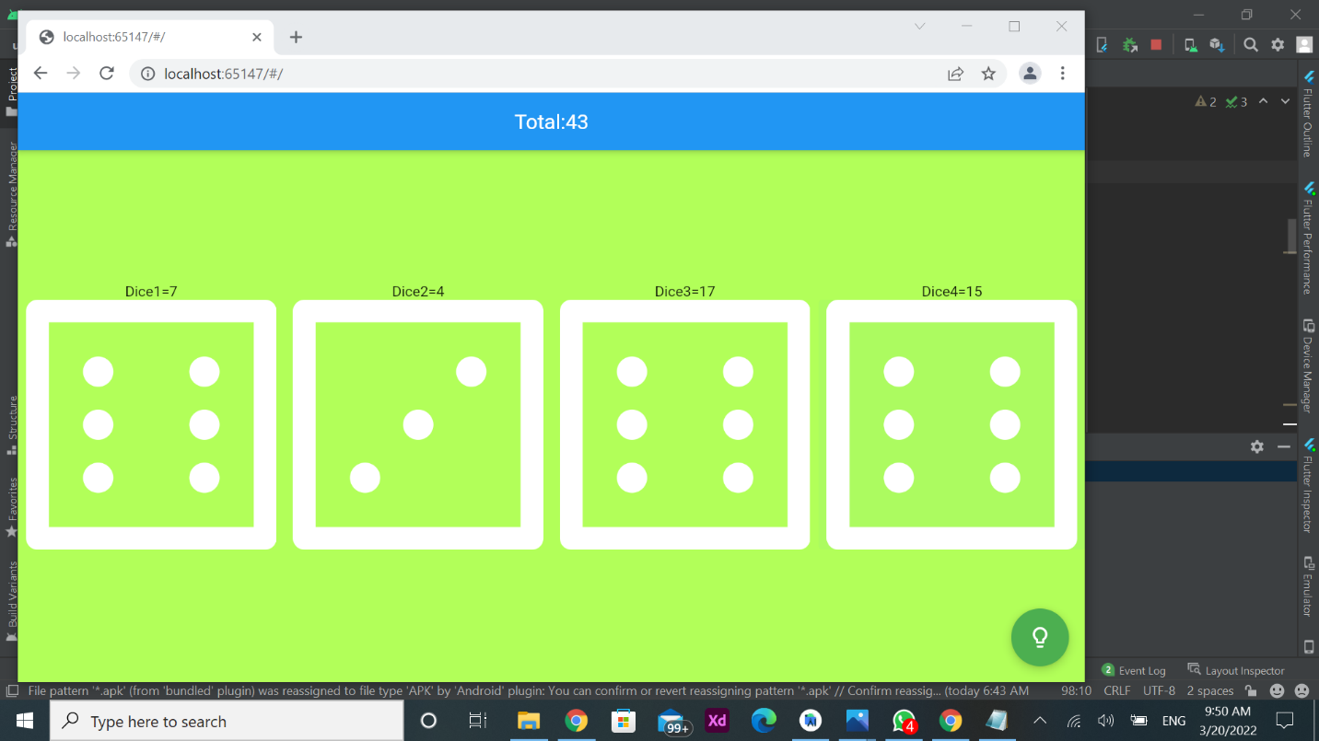

# Result:

# Github:

